**INTEGRATED PROJECT REPORT**

 On

**HEALTHPLUS**

Submitted in partial fulfilment of the requirement for the

Course Integrated Project (CS 203) of

**COMPUTER SCIENCE AND ENGINEERING**

**B.E. Batch-2020**

in

**JUNE-2023**

|  |  |  |  |  |  |  |  |  |  |  |  |
| --- | --- | --- | --- | --- | --- | --- | --- | --- | --- | --- | --- |
| **Under the Guidance of:**  Dr. Shilpi Harnal  Assistant Professor | **Submitted By:**   |  |  | | --- | --- | | **Name** | **Roll Number** | | Liza | 2010991608 | | Luckshay | 2010991610 | | Puneet Jain | 2010991674 | | Reeya Bansal | 2010991682 | |

**DEPARTMENT OF COMPUTER SCIENCE AND ENGINEERING**

**CHITKARA UNIVERSITY**

**PUNJAB**

**CERTIFICATE**

This is to be certified that the project entitled “HealthPlus” has been submitted for the Bachelor of Computer Science Engineering at Chitkara University, Punjab during the academic semester January, 2023 – May, 2023 is a Bonafede piece of project work carried out by “Luckshay (2010991610), Liza (2010991608), Puneet Jain (2010991674), Reeya Bansal (2010991682)” towards the partial fulfilment for the award of the course Integrated Project (CS 203) under the guidance of “and supervision.

**Sign. of Project Guide:**

Dr. Shilpi Harnal

Assistant Professor,

Department of Computer Science and Engineering

**CANDIDATE’S DECLARATION**

We, **“Luckshay (2010991610), Liza (2010991608), Puneet Jain (2010991674), Reeya Bansal (2010991682)”,** B.E.-2020 of the Chitkara University, Punjab hereby declare that the Integrated Project Report entitled **“HealthPlus”** is an original work and data provided in the study is authentic to the best of our knowledge. This report has not been submitted to any other Institute for the award of any other course.

|  |  |  |  |
| --- | --- | --- | --- |
| **Sign. of Student 1** | **Sign. of Student 2** | **Sign. of Student 3** | **Sign. of Student 4** |
| Liza | Luckshay | Puneet Jain | Reeya Bansal |
| ID No.: 2010991608 | ID No.: 2010991610 | ID No.: 2010991674 | ID No.: 2010991682 |

**Place:** Chitkara University, Rajpura

**Date:** 8th June,2023

**ACKNOWLEDGEMENT**

It is our pleasure to be indebted to various people, who directly or indirectly contributed in the development of this work and who influenced my thinking, behavior and acts during the course of study.

We express our sincere gratitude to all for providing me an opportunity to undergo Integrated Project as the part of the curriculum.

We are thankful to “**Dr. Shilpi Harnal**” for her support, cooperation, and motivation provided to us during the training for constant inspiration, presence and blessings.

We also extend our sincere appreciation to ***“Dr. Shilpi Harnal”*** who provided her valuable suggestions and precious time in accomplishing our Integrated Project Report.

Lastly, we would like to thank the almighty and our parents for their moral support and friends with whom we shared our day-to day experience and received lots of suggestions that improve our quality of work.

|  |  |  |  |
| --- | --- | --- | --- |
| **Liza** | **Luckshay** | **Puneet Jain** | **Reeya Bansal** |
| **ID No.: 2010991608** | **ID No.: 2010991610** | **ID No.: 2010991674** | **ID No.: 2010991682** |

**INDEX**

1. ABSTRACT/KEYWORDS 6
2. INTRODUCTION TO THE PROJECT 7

**2.1 Background** 7

**2.2 Problem Statement** 7

1. SOFTWARE AND HARDWARE REQUIREMENTS 9

**3.1 Methods** 9

**3.2 Programming/Working Environment** 11

**3.3 Requirements to run the application** 11

1. GUI ANALYSIS 12
2. CODE IMPLEMENTATION 27
3. SYSTEM TESTING 33
4. LIMITATIONS 34
5. CONCLUSION 35
6. FUTURE SCOPE 36
7. BIBLIOGRAPHY / REFERENCES 37

# ABSTRACT/KEYWORDS

**1.1 Abstract**

The HealthPlus application is a MERN stack project developed to streamline healthcare management.

It offers features such as appointment scheduling, digital medical record management, and efficient communication between patients and healthcare providers. It has a number of features that make it stand out from other healthcare management websites and apps including:

* Seamless Appointment Scheduling: Patients can easily book and manage appointments with healthcare providers, ensuring a smooth and convenient healthcare experience.
* Digital Medical Record Management: The app allows users to maintain their medical records digitally, eliminating the need for physical paperwork and enabling secure access to health information.
* Effective Communication: The application facilitates seamless communication between patients and healthcare providers through messaging and notification systems, improving the overall healthcare experience.

**1.2 Keywords**

* HealthCare Management System
* Patient-Doctor interaction
* Medical record management
* Appointment scheduling
* Quality healthcare services.

# INTRODUCTION TO THE PROJECT

## **2.1 Background**

The HealthPlus project was initiated to address the growing need for a streamlined healthcare management solution. With the increasing demand for efficient appointment scheduling, digital medical record management, and improved patient-provider communication, there was a need for a comprehensive application that could integrate these functionalities.

## **2.2 Problem Statement**

The lack of an efficient and integrated healthcare management system leads to challenges in appointment scheduling, medical record management, and communication between healthcare providers and patients.

**2.3 Project**

The objective of HealthPlus project is to create an advanced healthcare management application leveraging the MERN stack. By integrating modern technologies, the application aims to enhance healthcare services, streamline processes, and facilitate effective communication between patients and healthcare providers, ultimately improving the overall healthcare experience.

HealthPlus app provides a user-friendly interface for patients to easily book and manage their appointments with healthcare providers, streamlining the scheduling process and reducing administrative burdens.

With HealthPlus, users can maintain their medical records digitally, eliminating the need for physical paperwork and enabling secure access to their health information anytime, anywhere.

HealthPlus prioritizes the privacy and security of sensitive healthcare data. Robust measures are implemented to ensure data encryption, access control, and compliance with industry regulations, providing users with peace of mind.

# SOFTWARE AND HARDWARE REQUIREMENTS

## **3.1 Methods**

1. Modern UI/UX Design:

* The project incorporates modern UI/UX design principles to create an intuitive and visually appealing user interface.
* The use of React.js enables efficient state management and dynamic rendering of data, enhancing the user experience.
* CSS frameworks like Bootstrap or Material-UI may be utilized to enhance the design aesthetics and ensure responsiveness across different devices.

1. Data Storage and Retrieval:

* MongoDB, a NoSQL database, is utilized to store and manage healthcare-related data, including user inputs, medical records, and other relevant information.
* The Mongoose library may be used to facilitate object modeling and interaction with the MongoDB database.
* Data retrieval techniques such as querying and aggregation are implemented to fetch and process the required healthcare information.

1. Appointment Scheduling and Management:

* The project includes a robust appointment scheduling system that allows patients to easily book and manage their appointments with healthcare providers.
* The system handles appointment availability, conflict resolution, and reminders to ensure efficient scheduling and management.

1. Digital Medical Record Management:

* HealthPlus offers a secure and centralized platform for users to maintain and access their digital medical records.
* Users can securely store and manage their health information, eliminating the need for physical paperwork and enabling seamless access to medical records.

1. Communication and Messaging:

* The application facilitates seamless communication between patients and healthcare providers through messaging and notification systems.
* Patients can reach out to their doctors, ask questions, and receive timely updates regarding their healthcare.
* Healthcare providers can efficiently manage patient inquiries, respond promptly, and provide necessary guidance.

1. User Authentication and Authorization:

* The project implements user authentication mechanisms to secure access to the application and protect user data.
* Techniques such as password hashing and salting are employed to ensure the confidentiality and integrity of user credentials.
* Authentication libraries or frameworks such as Passport.js or JWT may be utilized for streamlined user authentication and authorization processes.

1. Integration of Third-Party APIs:

* The project may integrate third-party APIs to enhance functionality, such as integrating maps to show location of the facilities, payment gateways for seamless online transactions and SMS gateways for appointment reminders and notifications.

1. Scalability and Performance Optimization:

* The application is designed to handle a large volume of users and data, with optimizations in place to ensure scalability and performance.
* Techniques like caching, load balancing, and database indexing may be implemented to optimize the application's performance and responsiveness.

1. Continuous Testing and Improvement:

* The project follows a rigorous testing process to identify and resolve bugs, security vulnerabilities, and usability issues.
* Continuous improvements are made based on user feedback and emerging technologies to enhance the overall functionality and user experience of the application.

1. Deployment and Maintenance:

* The application is deployed to a reliable hosting environment namely, ensuring availability and stability.
* Regular maintenance activities, including security updates and bug fixes, are performed to keep the application running smoothly and securely.

## **3.2 Programming/Working Environment**

HealthPlus is programmed on MERN Stack based on HTML/CSS, JS, React, Express, MongoDB, NodeJS integrated with Python.

## **3.3 Requirements to run the application**

To run HealthPlus, you will need a web browser and an internet connection.

**The software requirements for HealthPlus are as follows:**

* A web browser
* An internet connection

**The hardware requirements for HealthPlus are as follows:**

* A computer with a minimum of 1GB of RAM
* A hard drive with a minimum of 10GB of free space

# GUI ANALYSIS

Observe the following screenshots to understand the User Experience Flow

**4.1 Home Page**

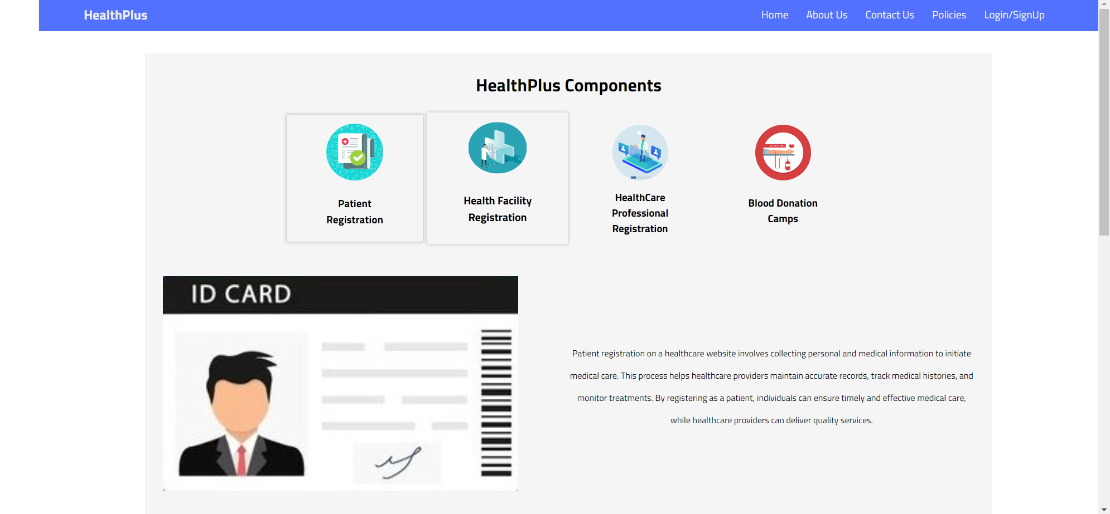

Figure 4.1.1

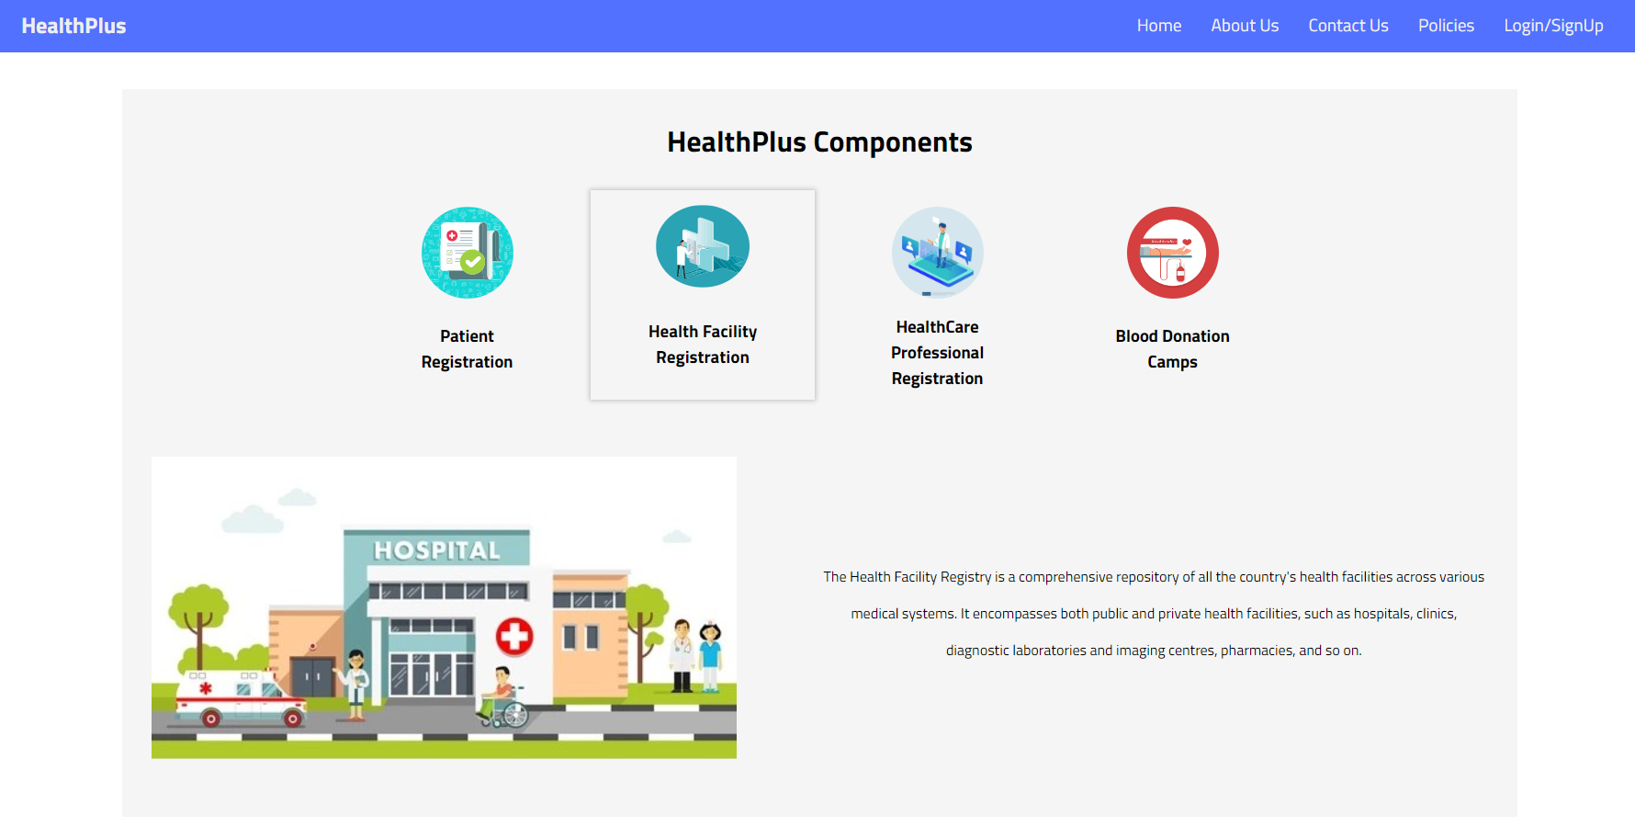

Figure 4.1.2

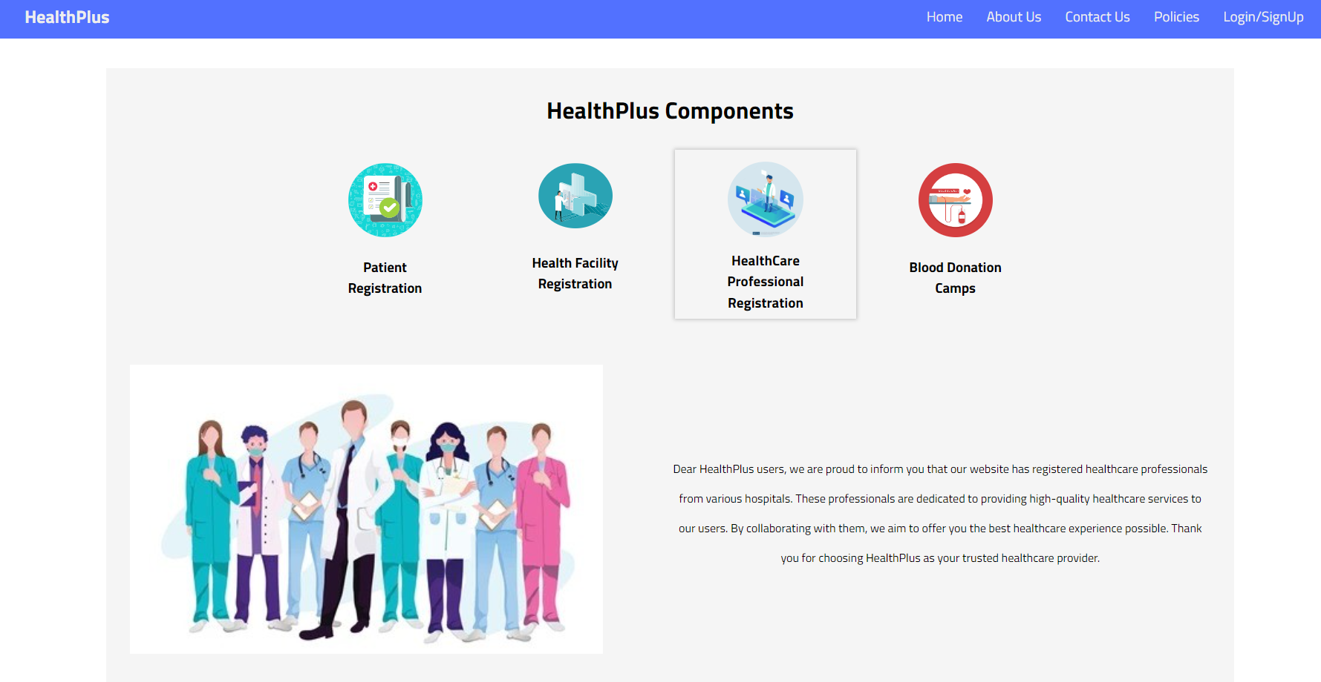

Figure 4.1.3

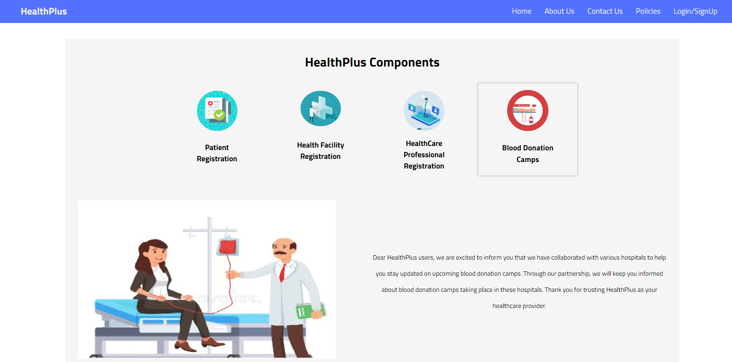

Figure 4.1.4

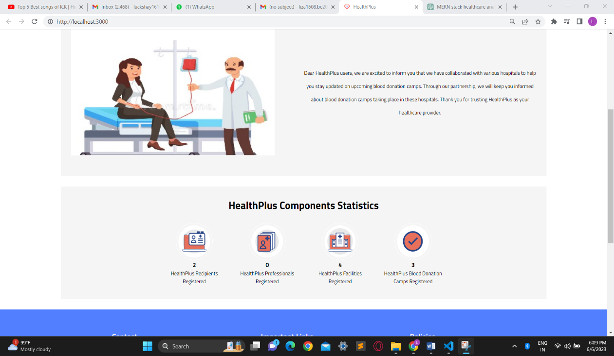

Figure 4.1.5

**4.2 About Us Component**

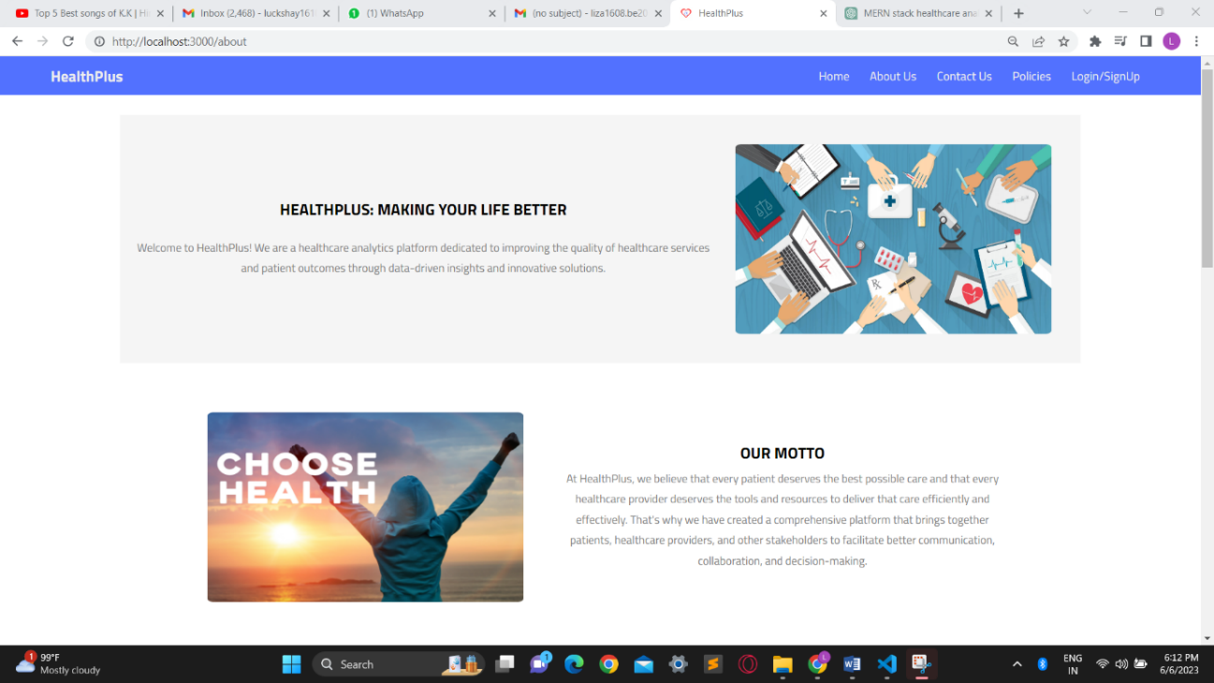

Figure 4.2.1

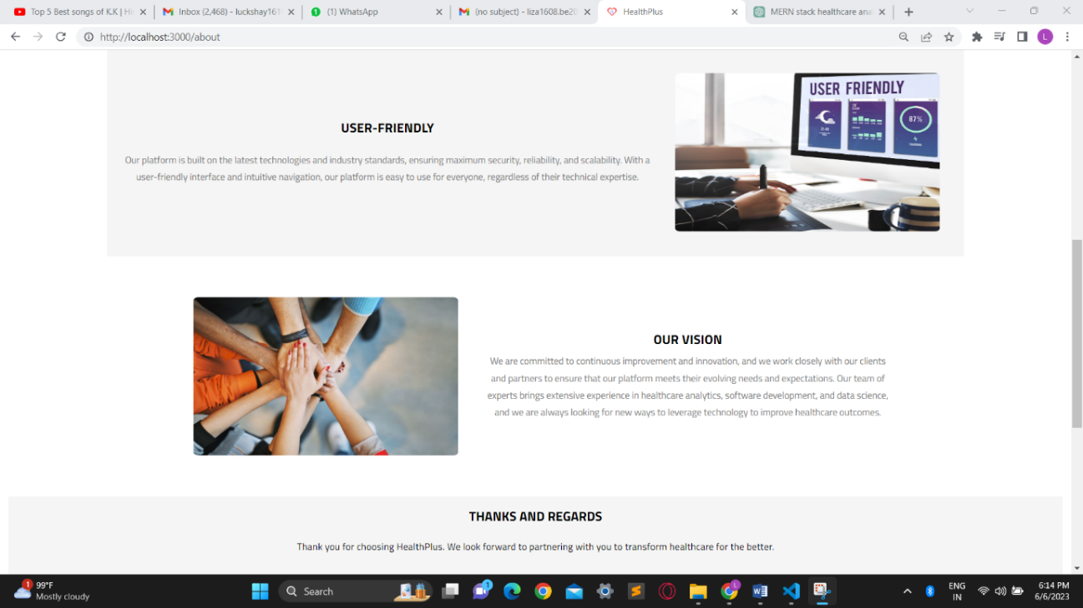

Figure 4.2.2

**4.3 Contact Us**

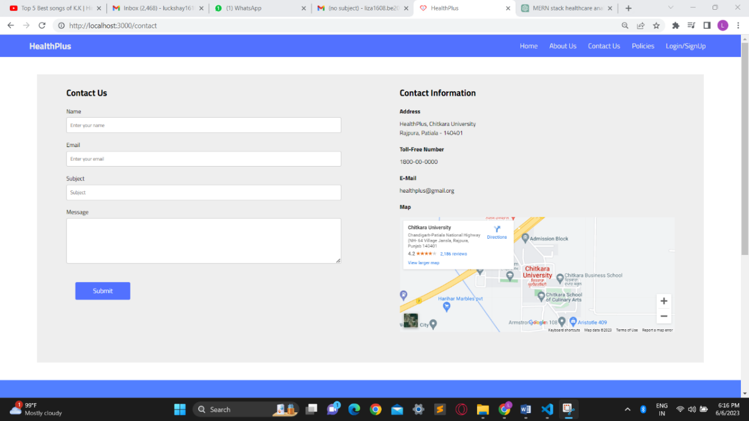

Figure 4.3.1

**4.4 Policies**

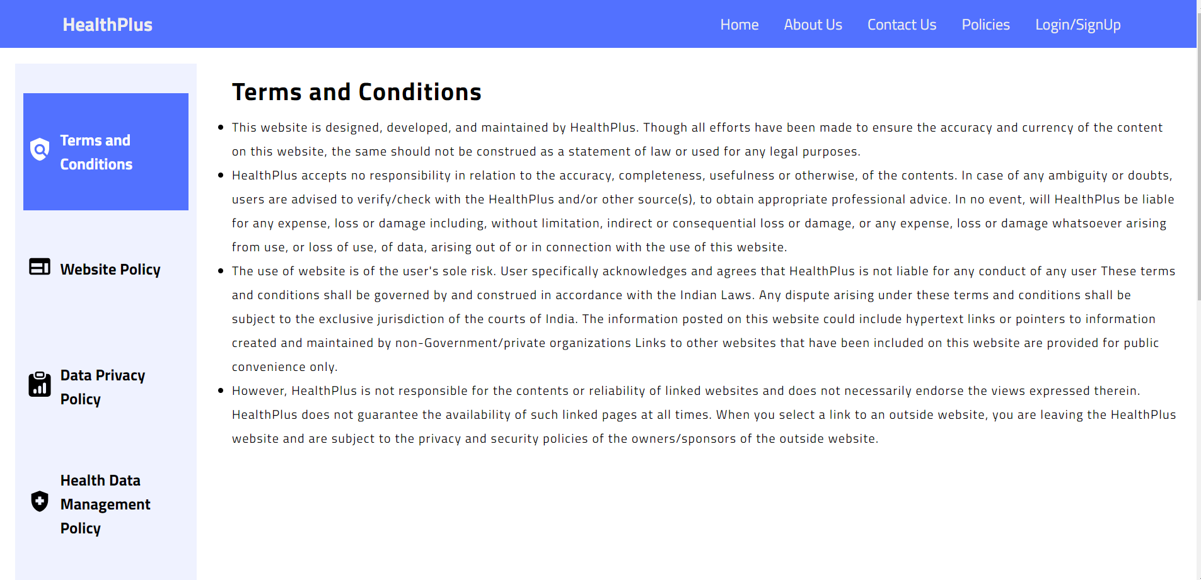

Figure 4.4.1

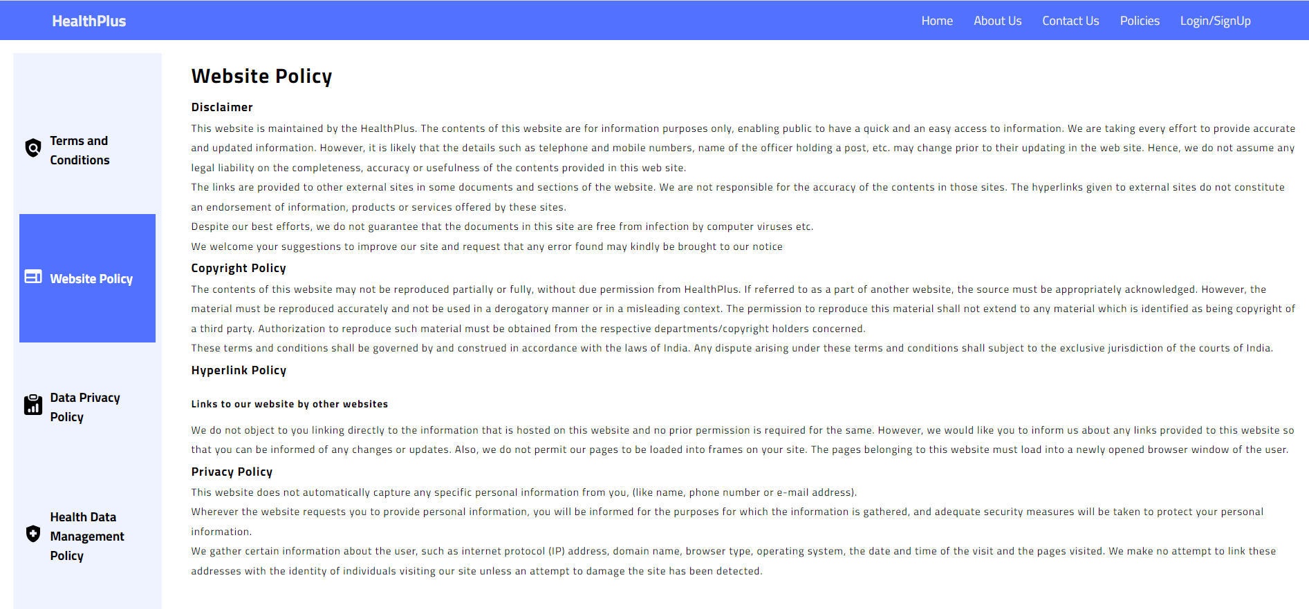

Figure 4.4.2

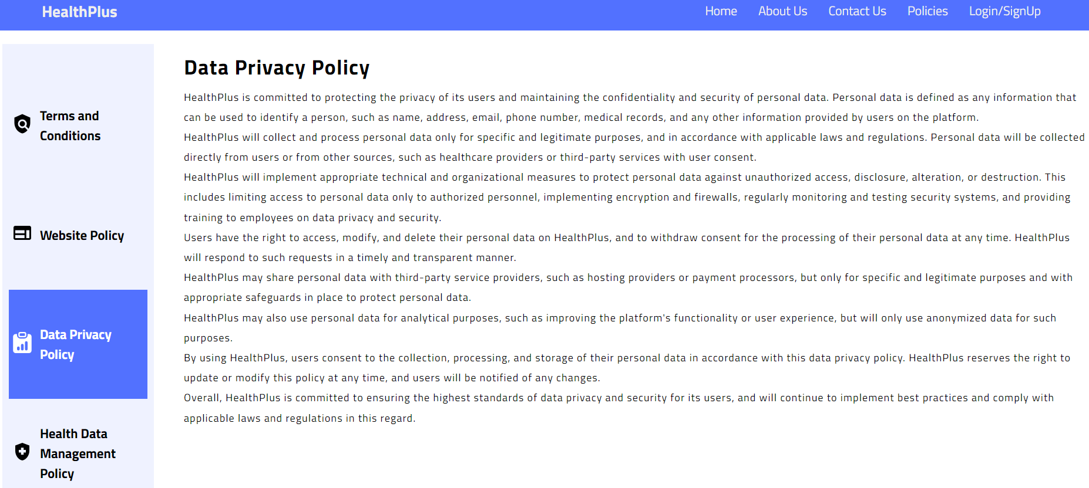

Figure 4.4.3

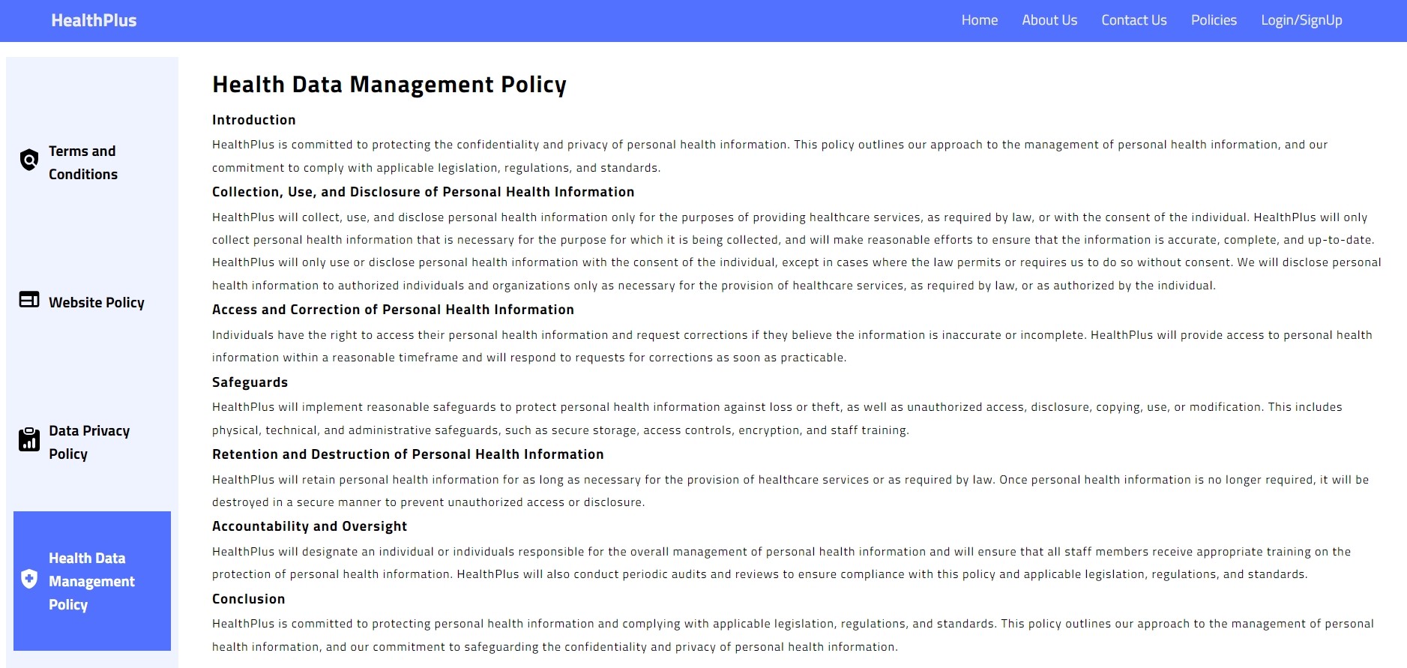

Figure 4.4.4

**4.5 Footer**

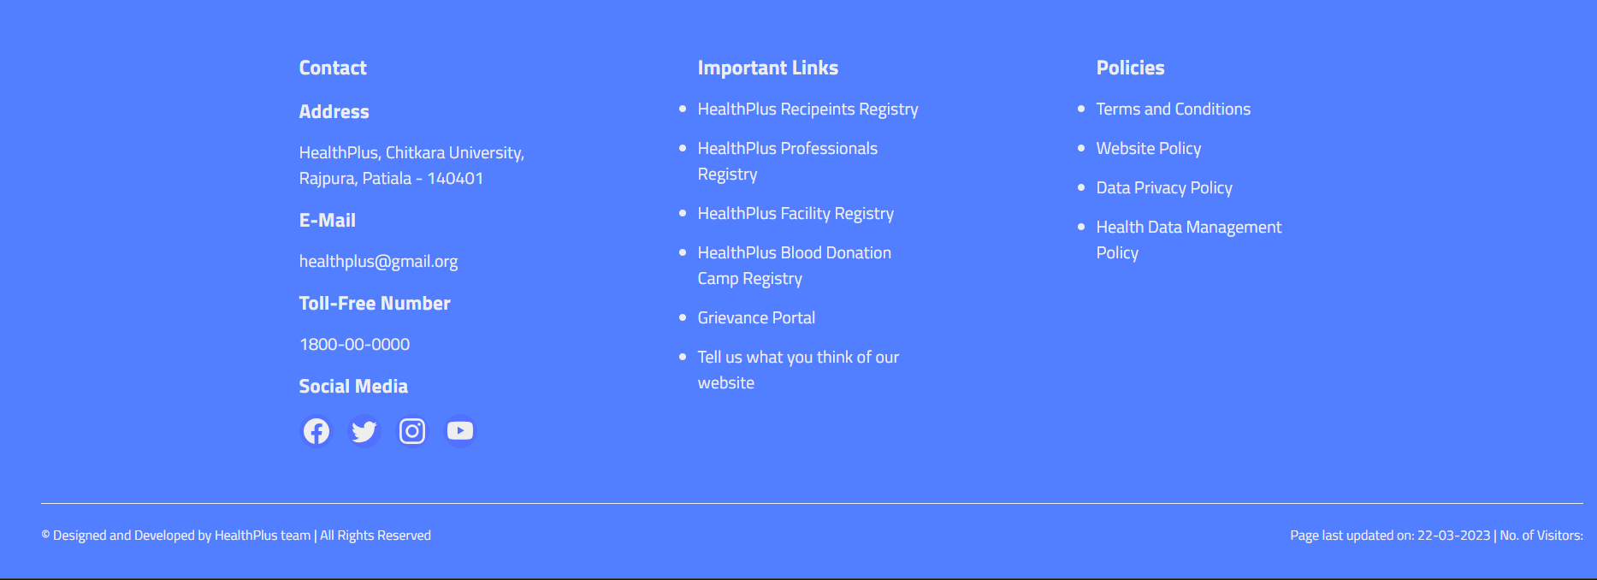

Figure 4.5.1

**4.6 Signup**

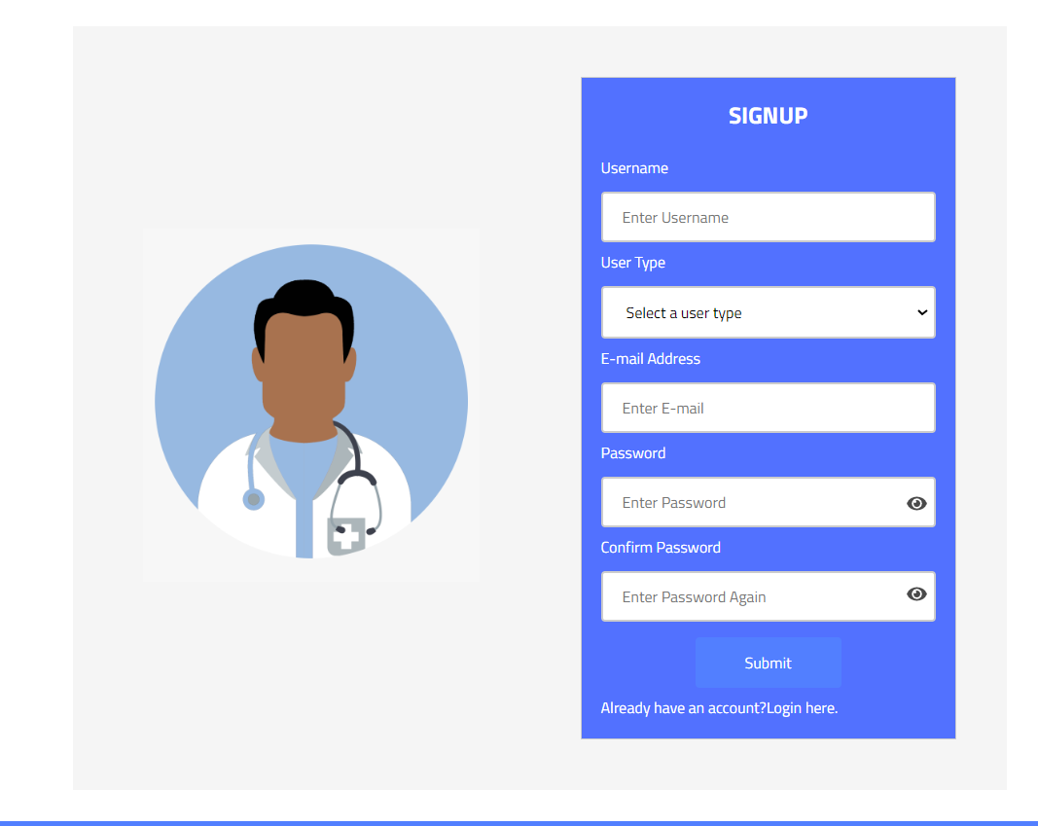

Figure 4.6.1

**4.7 Login**

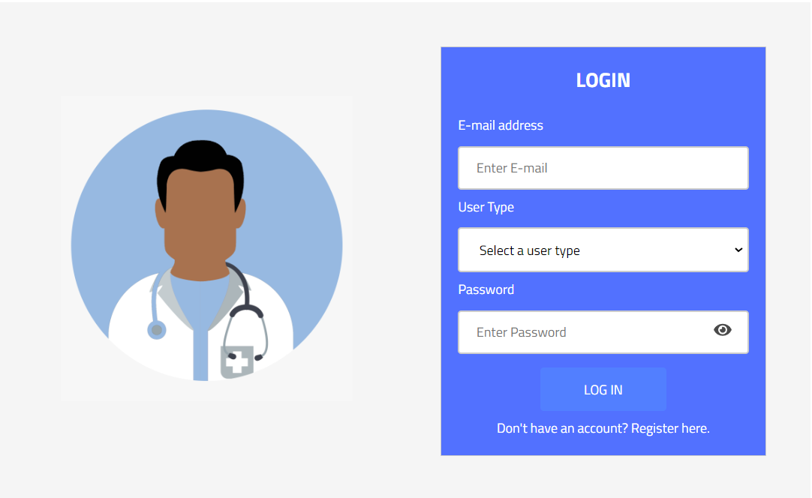

Figure 4.7.1

**4.8 Recipient Dashboard**

**4.8.1 Home**

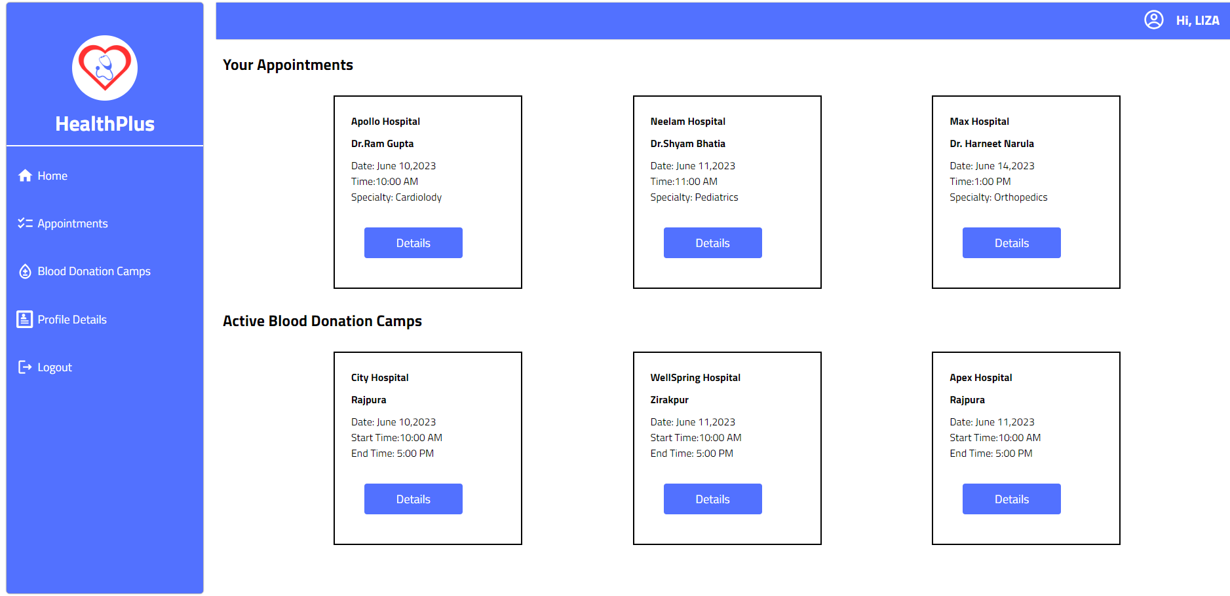

Figure 4.8.1

**4.8.2 Profile Details**

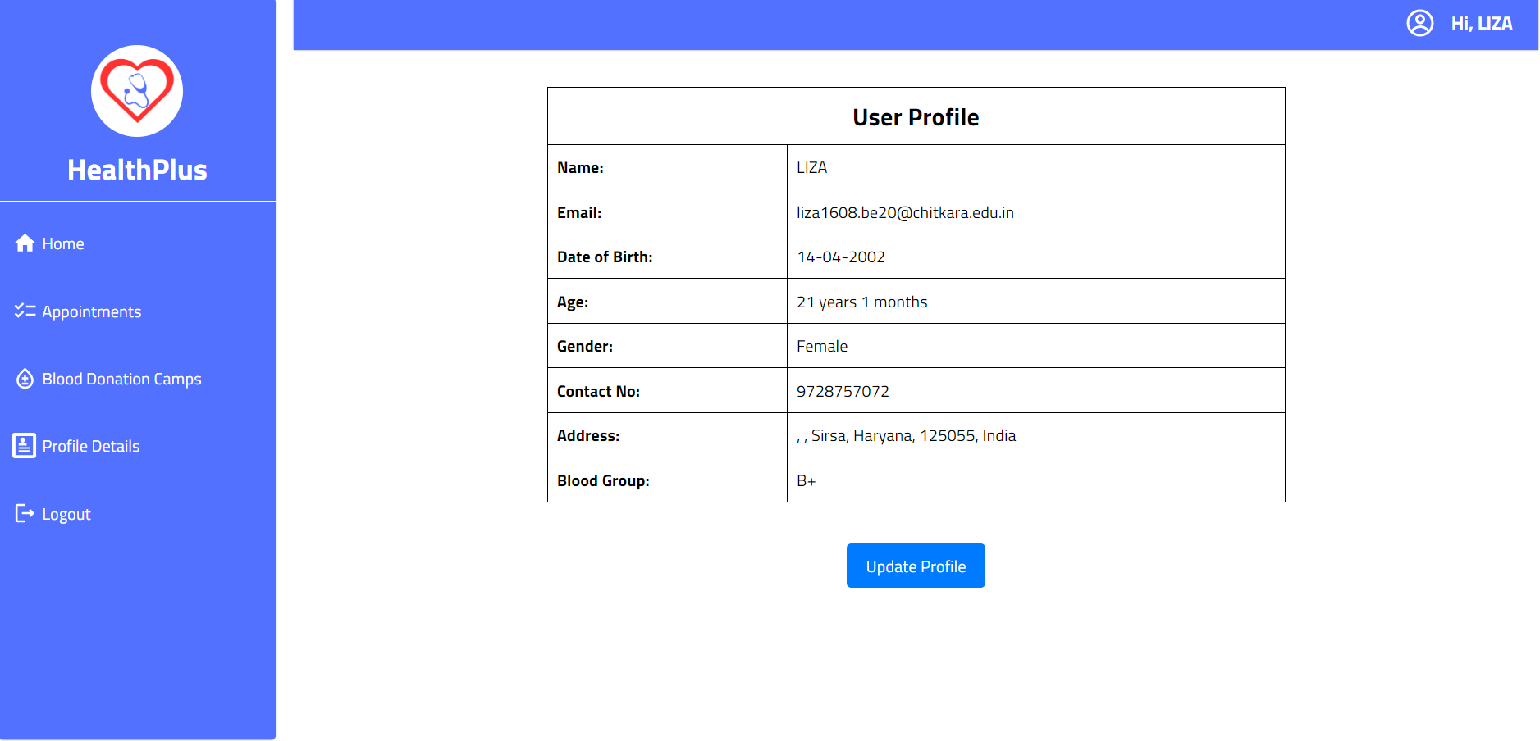

Figure 4.8.2

**4.8.3 Active Blood Donation Camps**

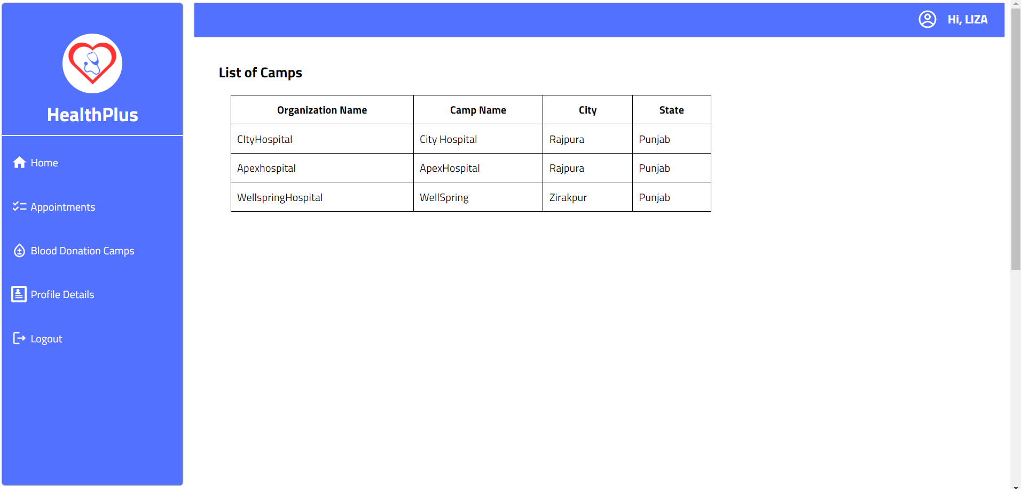

Figure 4.8.3

**4.8.4 Appointments**

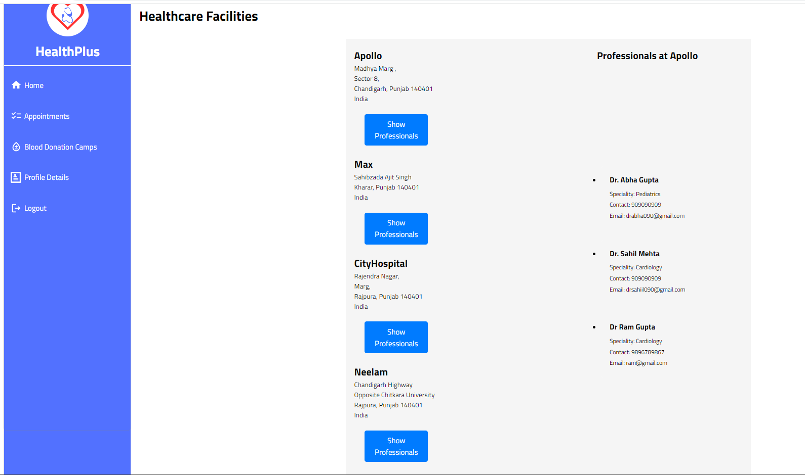

Figure 4.8.4

**4.9 HealthCare Facility Dashboard**

**4.9.1 Home**

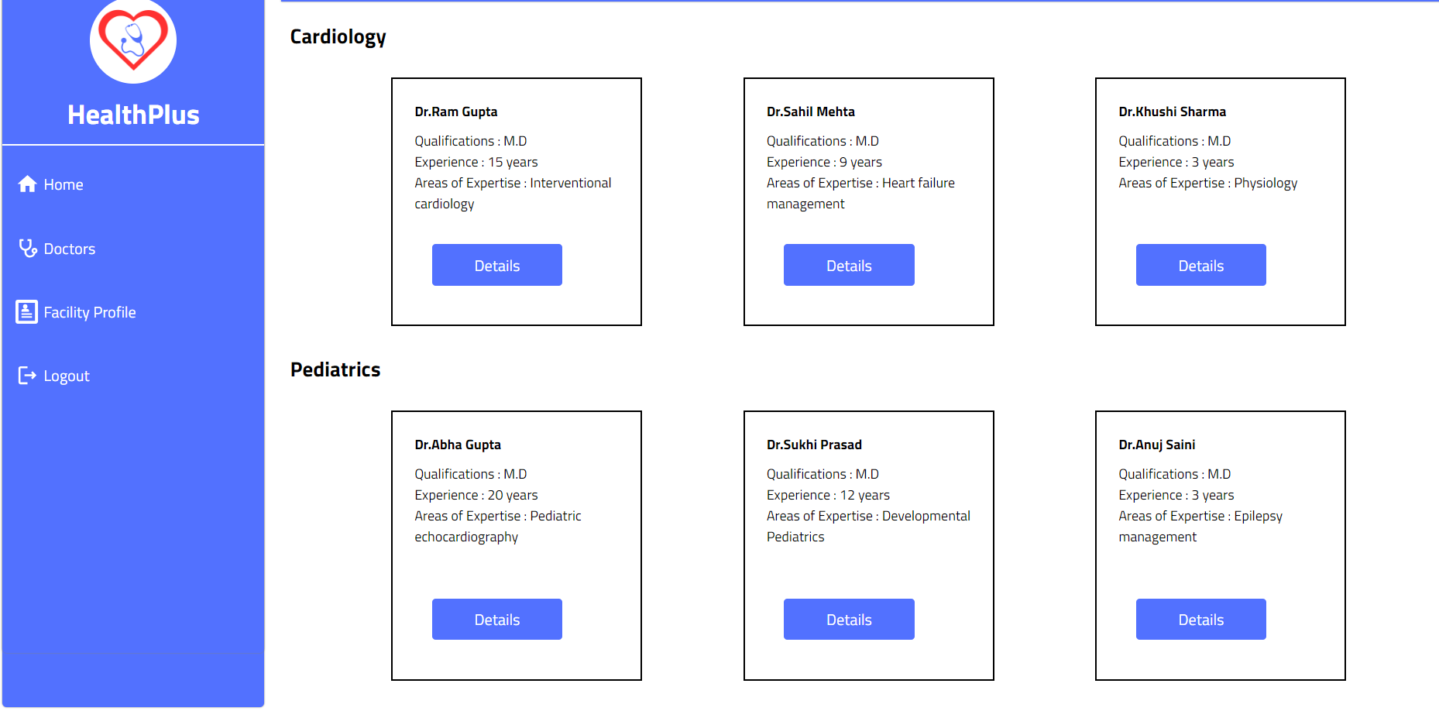

Figure 4.9.1

**4.9.2 Facility Profile**

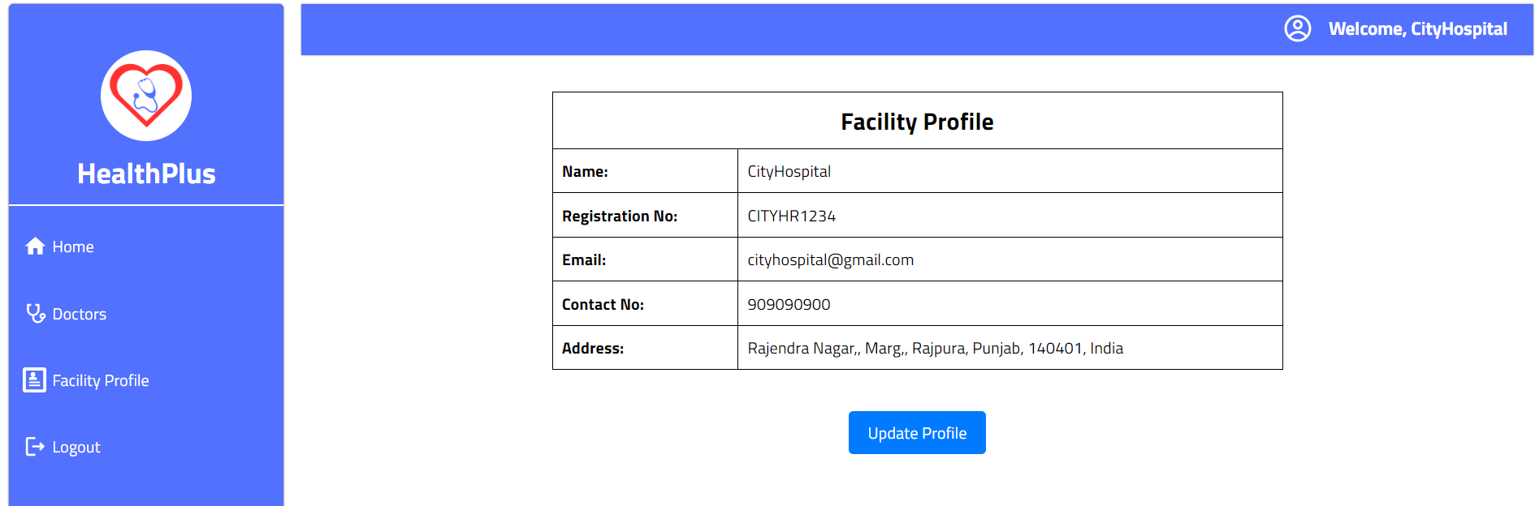

Figure 4.9.2

**4.9.3 Doctors Component**

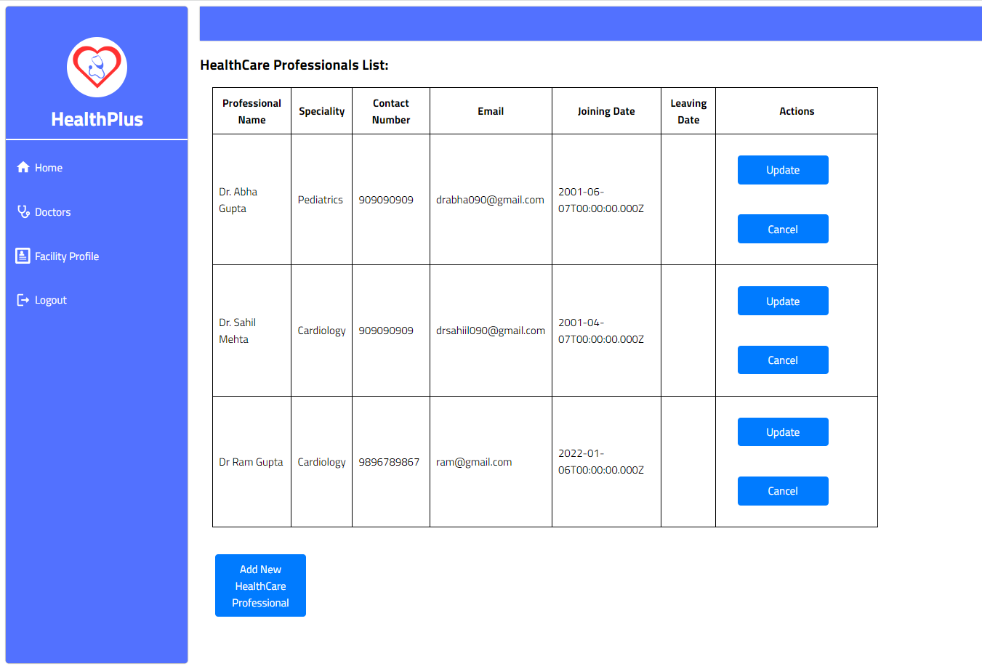

Figure 4.9.3

**4.10 Blood Donation Camp Dashboard**

**4.10.1 Blood Donation Camps**

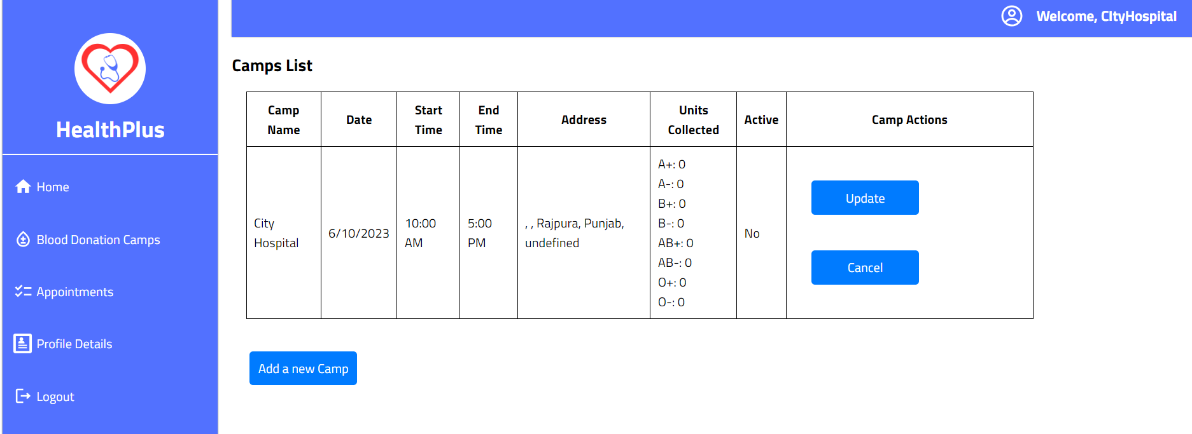

Figure 4.10.1

# CODE IMPLEMENTATION

The code can be accessed at: https://github.com/luckshay/HealthPlus-Project.git

**5.1 Home Page**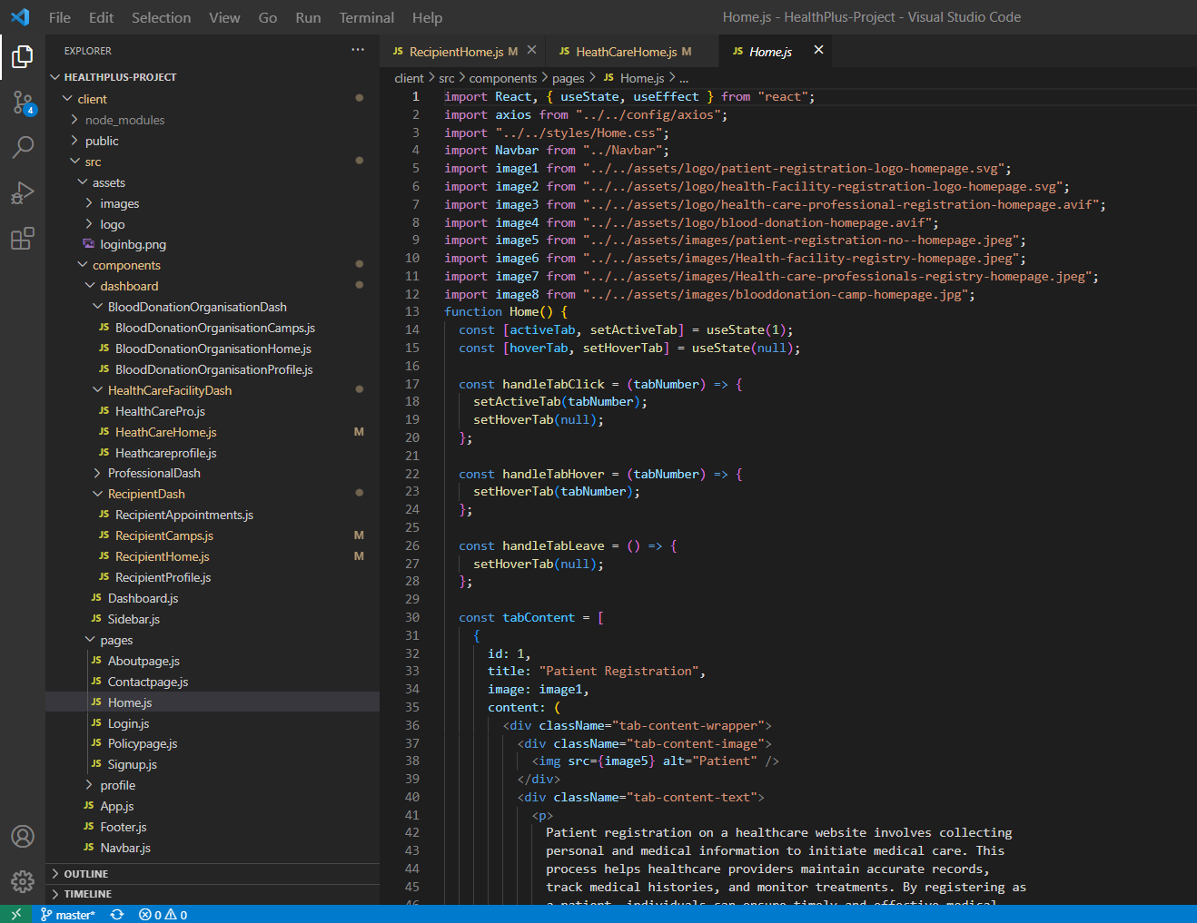

Figure 5 1

**5.2 About Page**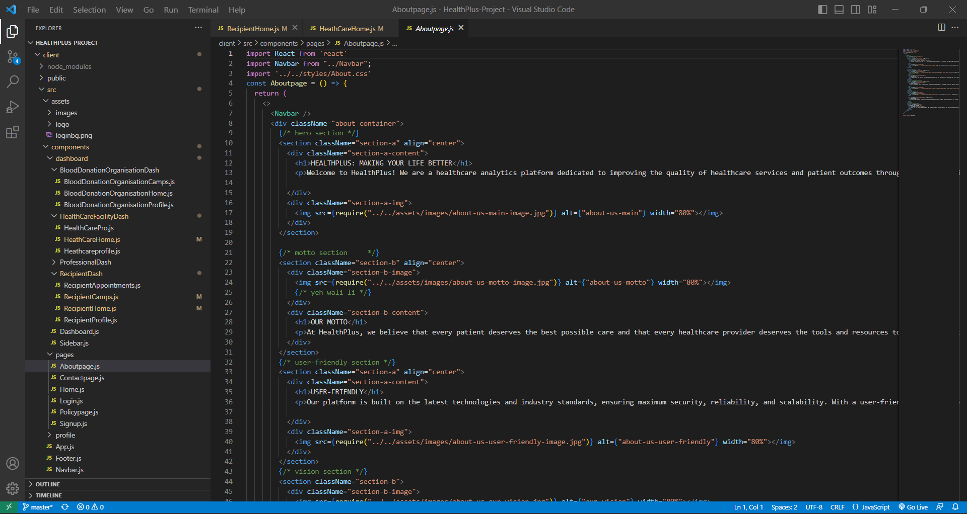

Figure 5.2

**5.3 Contact Page**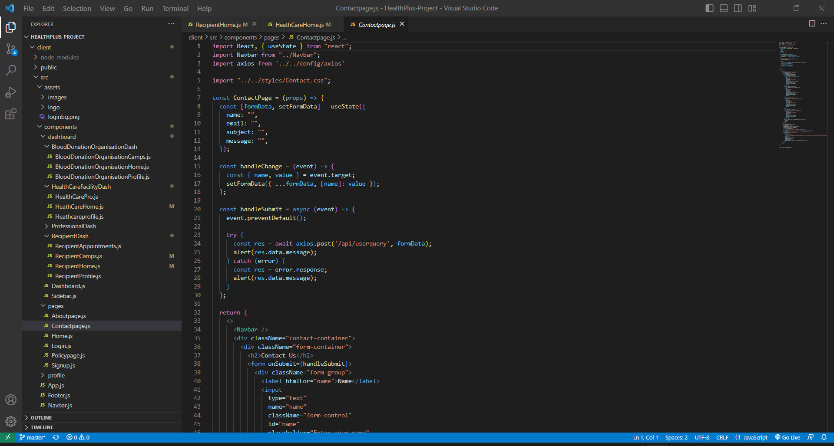

Figure 5.3

**5.4 Policy Page**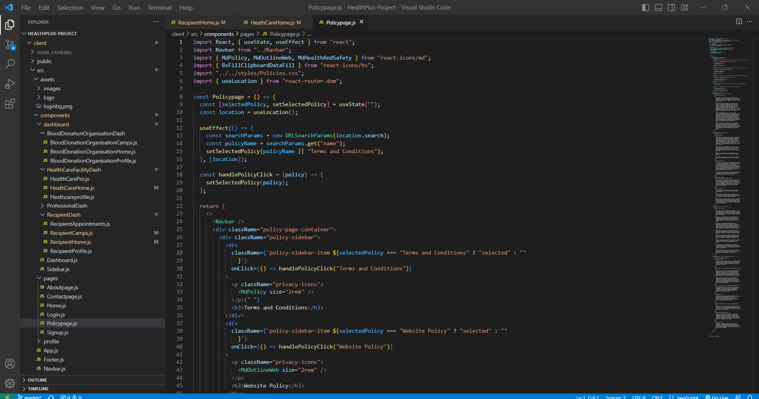

Figure 5.4

**5.5 Login Page**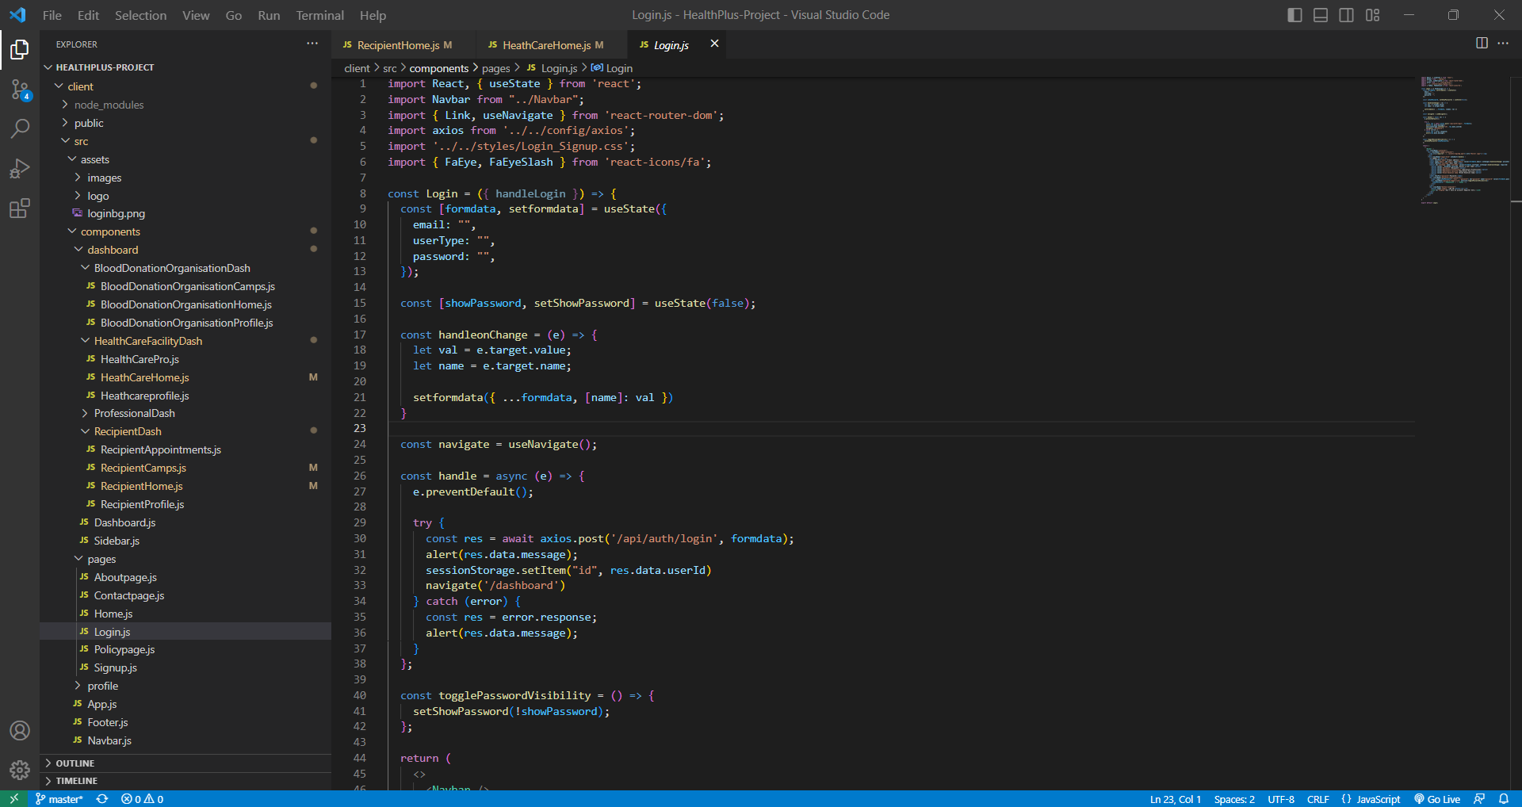

Figure 5.5

**5.6 Signup Page**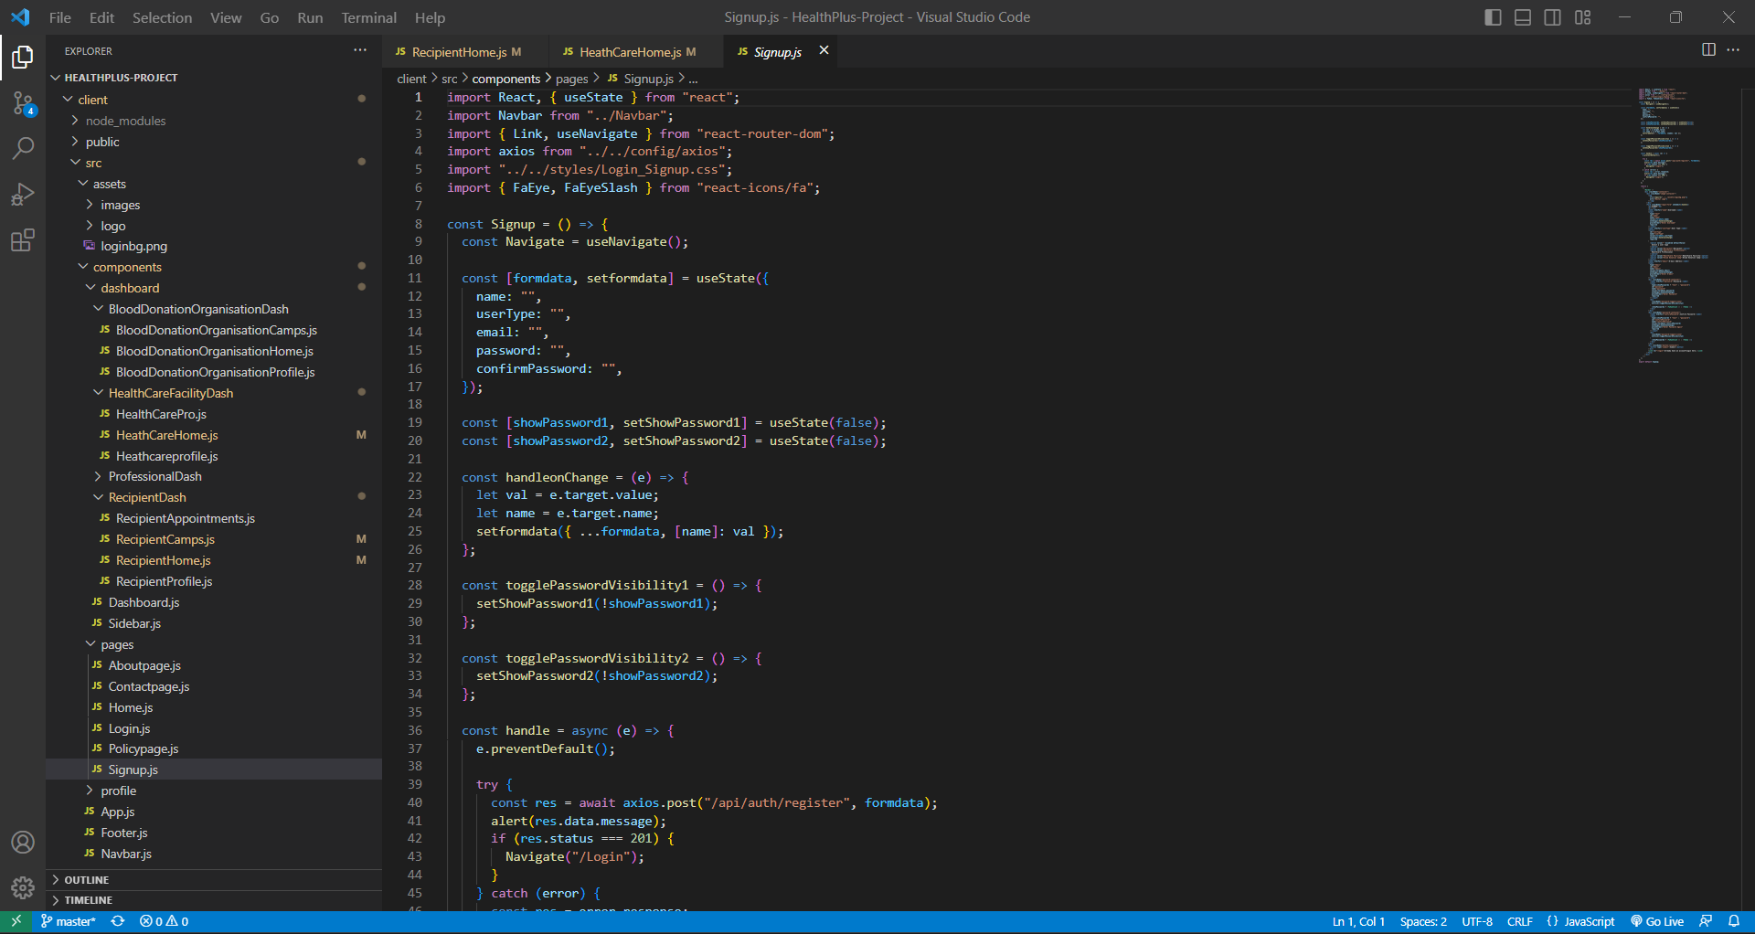

Figure 5.6

# SYSTEM TESTING

At the development level, each function written was tested in isolation for its functionality and then added to the development environment. Then, after developing the single functionality, it was unit tested to check if it behaves as expected. We included each and every test case we can think of. Afterwards, integration testing was performed to check for any integration issues. At the end, when the application was deployed, we performed Performance testing and Regression testing to check how the application performed in different scenarios. Finally, the team reviewed the metrics and found it at par with the standards.

# LIMITATIONS

Limitations of HealthPlus Project:

* Connectivity Dependence: The functionality of HealthPlus relies heavily on internet connectivity. Users may face limitations in accessing the app or performing certain functions in areas with poor or no internet connectivity.
* User Adoption: The success of HealthPlus depends on user adoption and willingness to embrace digital healthcare solutions. Some users, particularly elderly or less tech-savvy individuals, may face challenges in adapting to the app, limiting its reach.
* HealthPlus focuses on specific healthcare management aspects, such as appointment scheduling and medical record management. It may not encompass all aspects of healthcare delivery, and users may need to rely on additional resources or platforms for comprehensive healthcare needs.

Despite these limitations, HealthPlus offers valuable healthcare management functionalities and has the potential to enhance patient care, improve efficiency, promote digital transformation, increase accessibility to healthcare services, streamline medical record management, facilitate effective communication between patients and healthcare providers, and provide convenient appointment scheduling. The application strives to overcome the limitations through continuous improvements, addressing user feedback, and incorporating emerging technologies to ensure a comprehensive and user-centric healthcare solution.

Overall, HealthPlus is a modern healthcare management solution that streamlines services, improves patient care, and enhances accessibility. Despite limitations, it offers valuable functionalities for appointment scheduling, medical records, and secure communication. HealthPlus aims to revolutionize healthcare for better outcomes.

# CONCLUSION

In conclusion, The HealthPlus project is a comprehensive healthcare management solution that leverages modern technologies to streamline various aspects of healthcare services. It offers valuable functionalities such as appointment scheduling, digital medical record management, and secure communication between patients and healthcare providers.

The project demonstrates the potential of the MERN stack in developing robust and user-centric healthcare applications. Despite limitations, the HealthPlus project holds great promise in improving healthcare accessibility, efficiency, and patient care.

The successful development of the HealthPlus project highlights the significance of technology in revolutionizing the healthcare industry and addressing key challenges in healthcare management.

I hope that you have found HealthPlus to be a useful and enjoyable resource. Thank you for using HealthPlus!

# FUTURE SCOPE

The future scope of HealthPlus is vast. There are many ways that the project can be improved and expanded. Here are a few ideas:

* Collaborations with healthcare institutions, clinics, and hospitals can lead to partnerships and integrations, making HealthPlus a preferred platform for healthcare providers and patients.
* Continuous updates and improvements in security measures can ensure the protection of sensitive health information and maintain data privacy.
* The project can consider incorporating electronic health records (EHR) interoperability standards to facilitate seamless data exchange between different healthcare systems and improve continuity of care.
* Exploring possibilities for AI-driven chatbots or virtual assistants can enhance user experience by providing instant support and guidance.

I believe that with its strong foundation and continuous development, the HealthPlus project has the potential to revolutionize the healthcare industry and improve access to quality healthcare services.

# BIBLIOGRAPHY / REFERENCES

1. MERN Documentation:
   1. MongoDB. (n.d.). Retrieved from https://www.mongodb.com/
   2. Express.js. (n.d.). Retrieved from https://expressjs.com/
   3. React. (n.d.). Retrieved from https://reactjs.org/
   4. Node.js. (n.d.). Retrieved from https://nodejs.org/
2. Chat-GPT:
   1. Open AI. (n.d.). Chat-GPT. Retrieved from https://chat.openai.com/
3. NDHM App:
   1. National Digital Health Mission. (n.d.). Retrieved from https://ndhm.gov.in/